

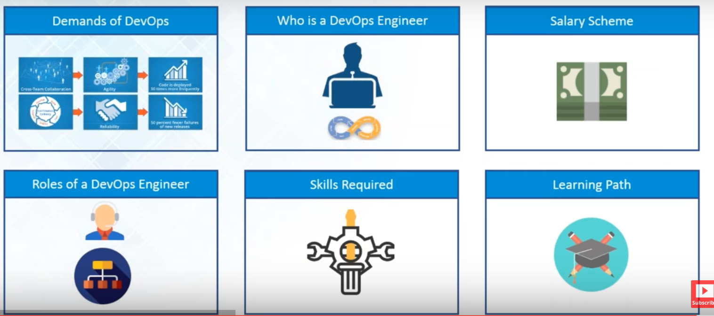

Devops brings 6 things mainly and all are interconnected.

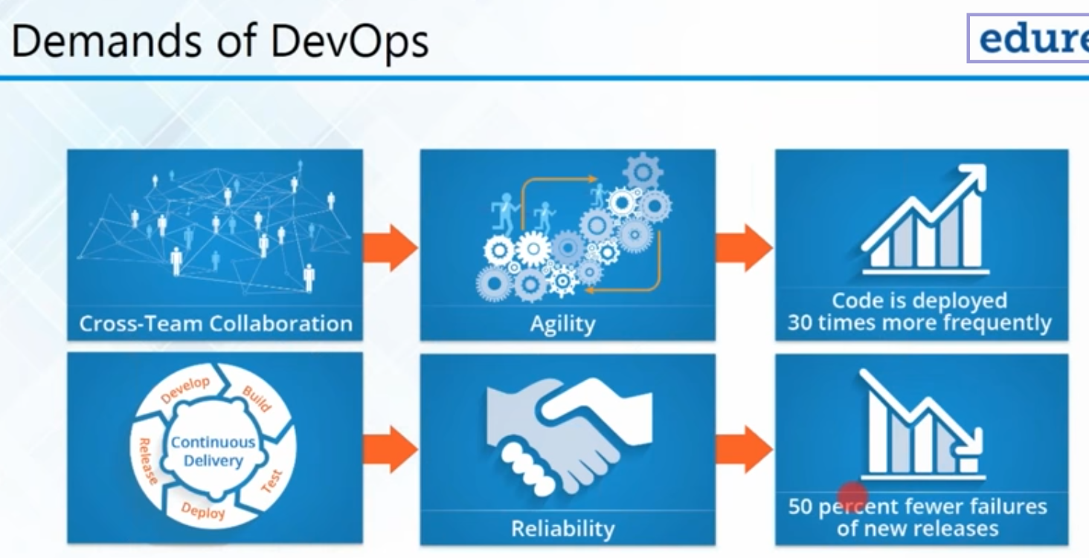

**Cross-collaboration:** Devops is emerged of the two words development and operations. Main aim of DevOps to integrate all these teams together.

In Devops, there is only one team and everyone knows what is happening in the company or how your software our application is actually getting developed and deployed on to the production server.

So member in the development team would know what is going on in the operations and testing and similarly a person in testing team would know what is going on in the development team and their operations team and so on and what happens with a Cross-collaboration.

**Agility (speed):** let's say you are a developer and you're developing your software.. so if a person in the operations team already know that what Source code/what is getting developed …,what kind of code they're going to deal with later after the development is over They can start configuring servers.. that test servers and production servers according to the code that the developers are producing and

similar way if the developer already knows that how the operations team has actually configured all the servers they can start writing the code that is compatible with the considerations of the servers that the operation team made …

So there is transparency everyone knows what is going on in what team and how this after is getting deployed from the start to the end and hence you can actually achieve better agility not only in the developers side but in the testing and operation and everywhere.

**Frequency:** Tests have actually shown that the code is actually deployed almost 30 times faster with Devops

Continuous delivery: Devops gives CD of product.

Continuous development-> build ->test-> deploy-release

Now if you're using the old method where you have to finish developing first and then go to testing and production it takes a lot of time but if everything is happening continuously newer releases are made even more frequently and it actually makes your code and your products more **reliable** and if you see the results you'll find that there are **50 person less failures** of the new releases with Devops.

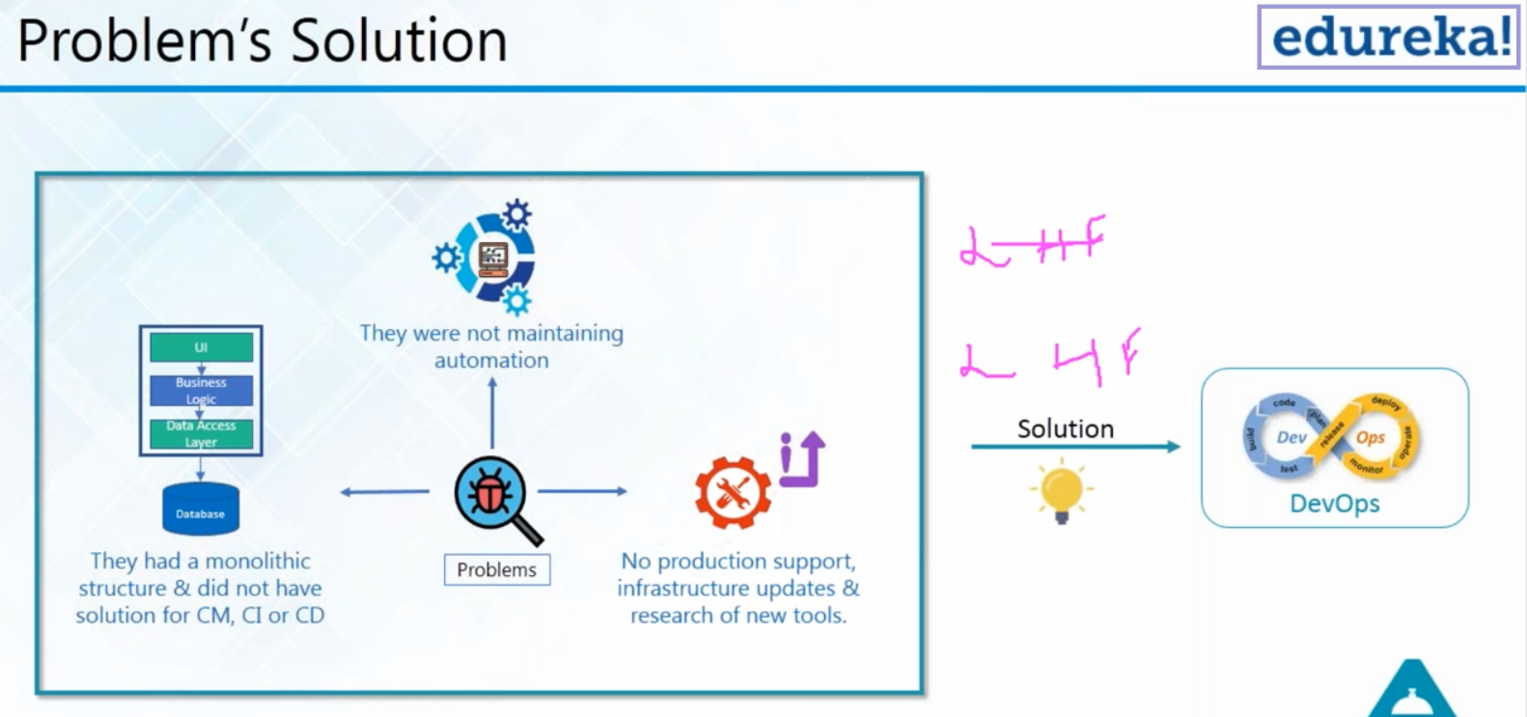

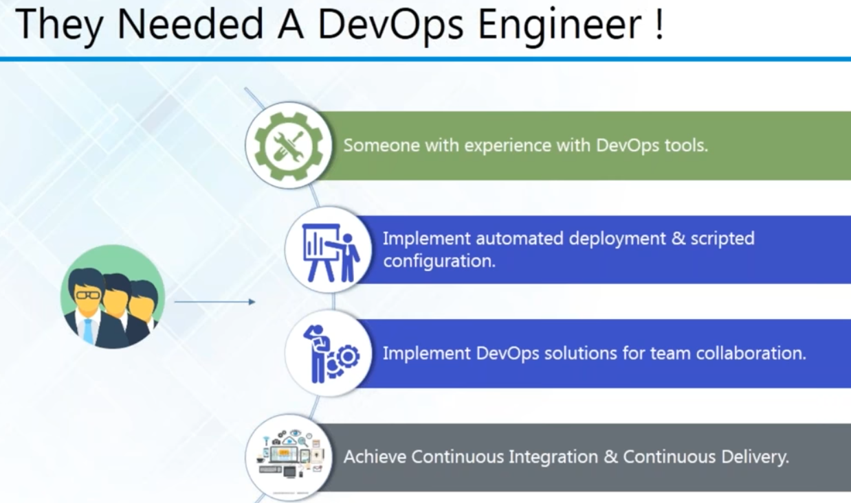

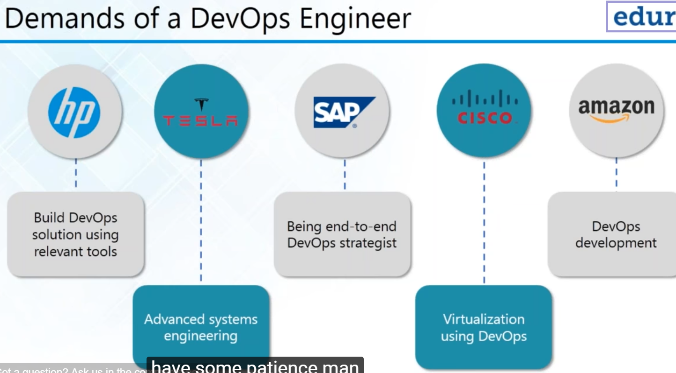

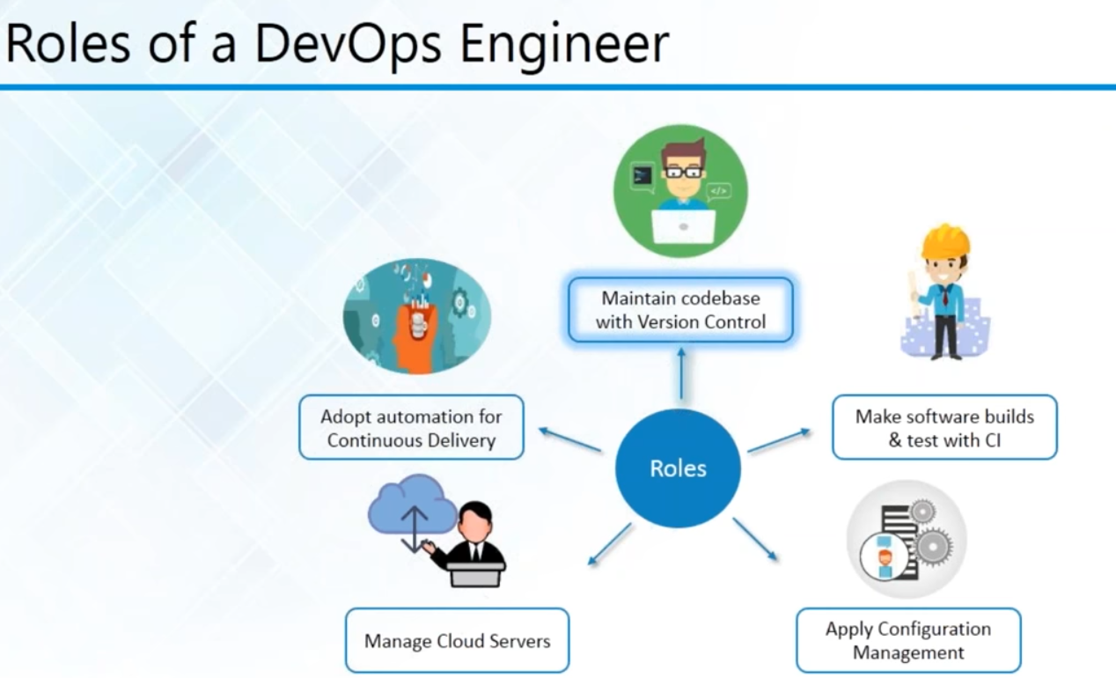

Manage Cloud: ecommerce flipkart-> load balancers big billion day

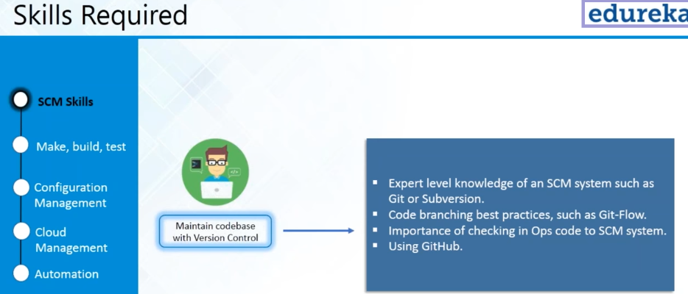

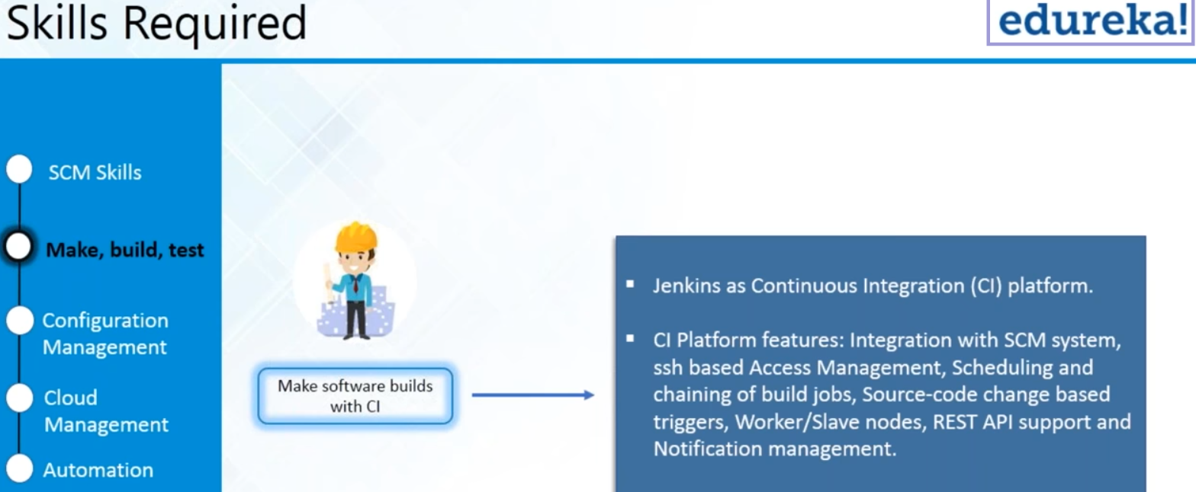

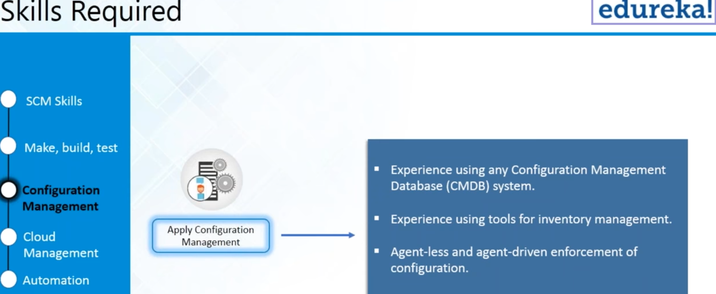

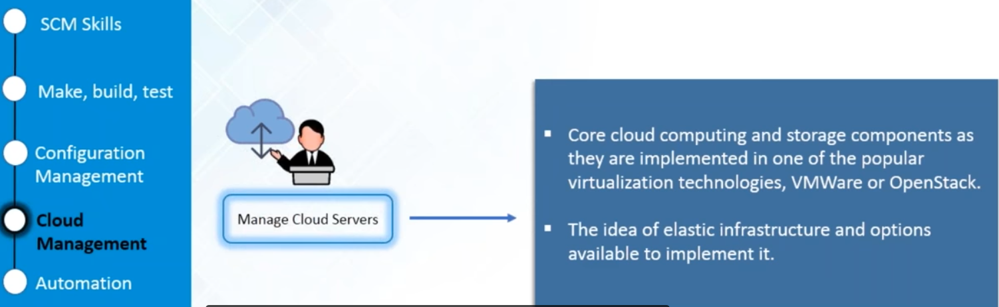

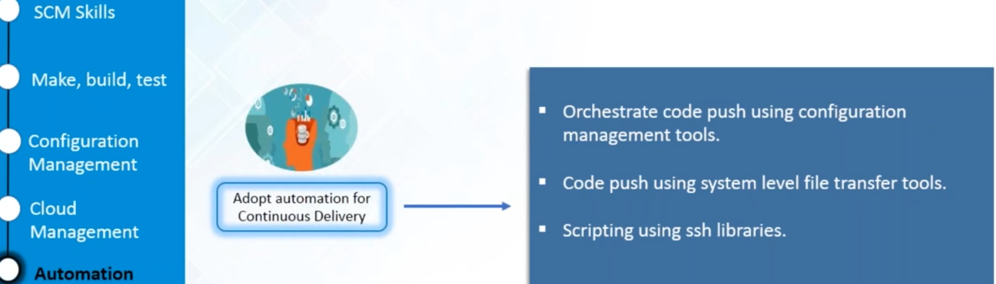

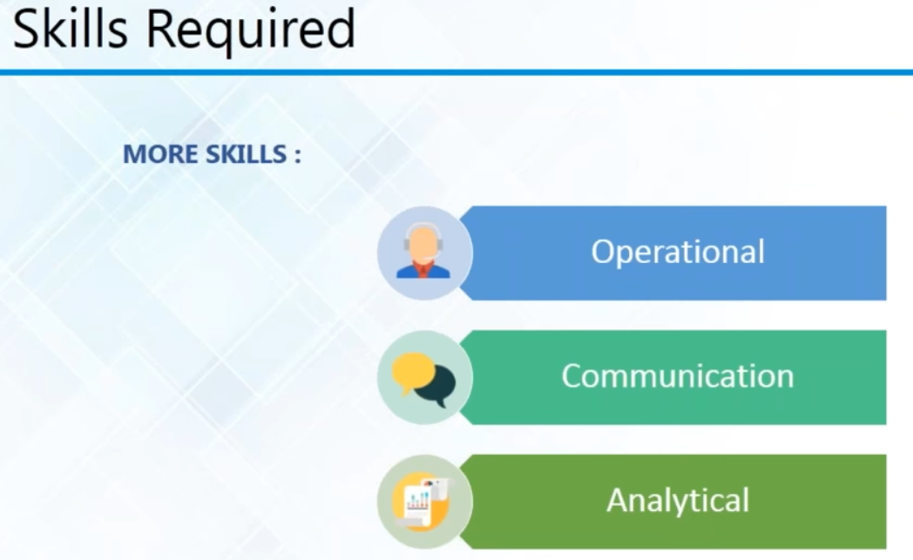

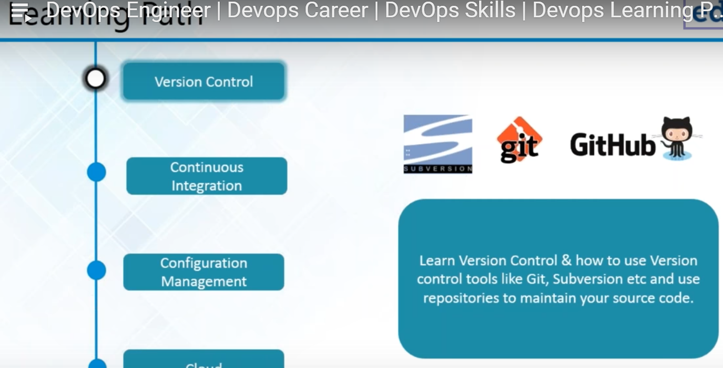

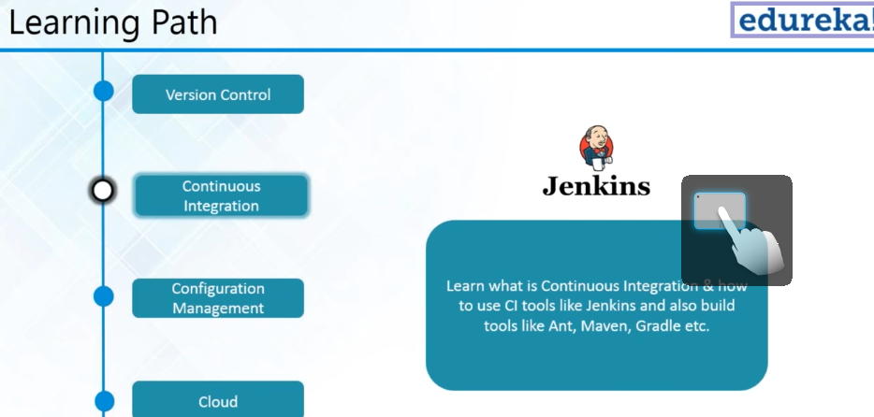

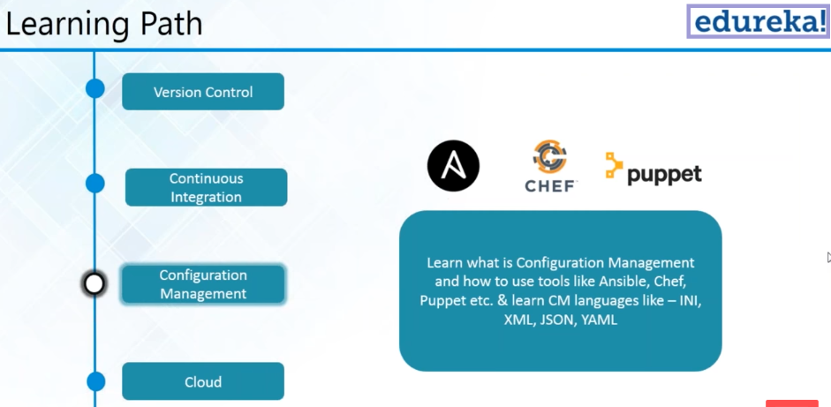

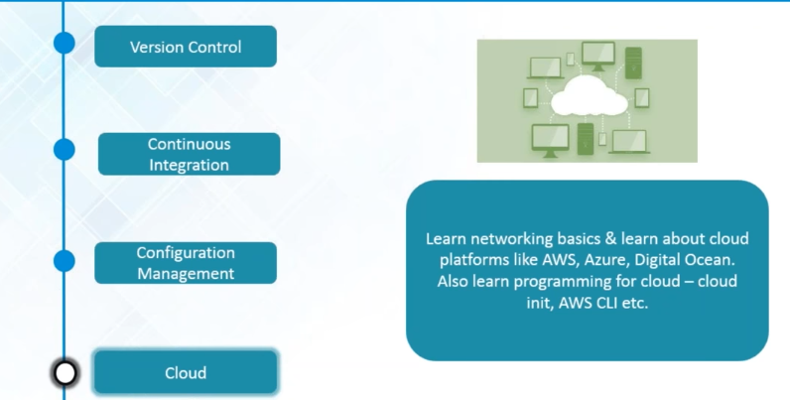

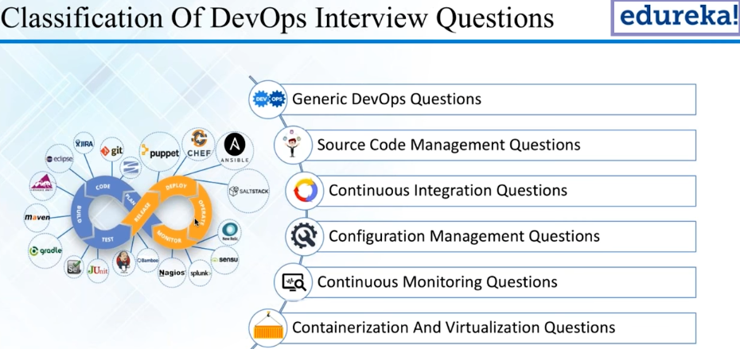

what is devops ,need of devops

What is the driving factor for Devops

Sdlc: starts with the planning stage ->code -> build ->test->Release -> deploy-> Release->

-> Start using that's called application -> monitoring

SVN: store the code

JIRA is basically to track devt , issue tracking tool , requirement gathering tool

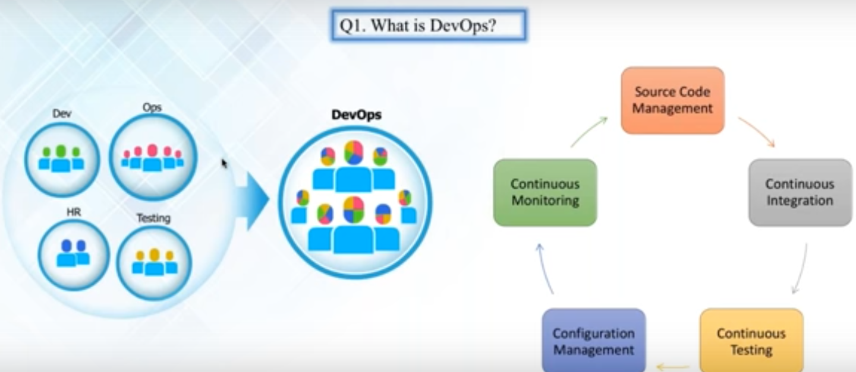Devops practice that actually brings developers and operations and HR testing and their activities/operations together in a collaborative fashion using proper processing techniques to achieve the fastest and reliable software releases ultimate purpose of the DevOps is to actually give a faster releases with high-quality that's the **main purpose**

source code management is one of the area continuous integration is another area continuous testing is one of the area's configuration management which also has a infrastructure as code is one area continuous monitoring is another area all these years together combined and can be called it a **DevOps practices**

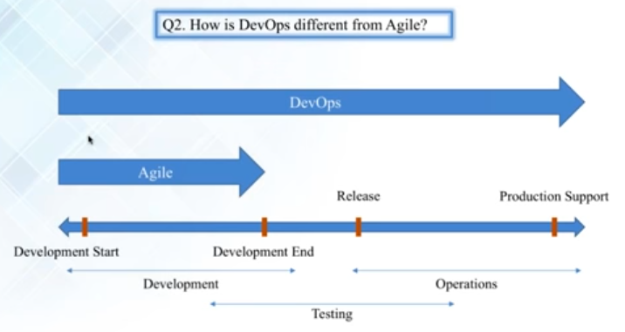

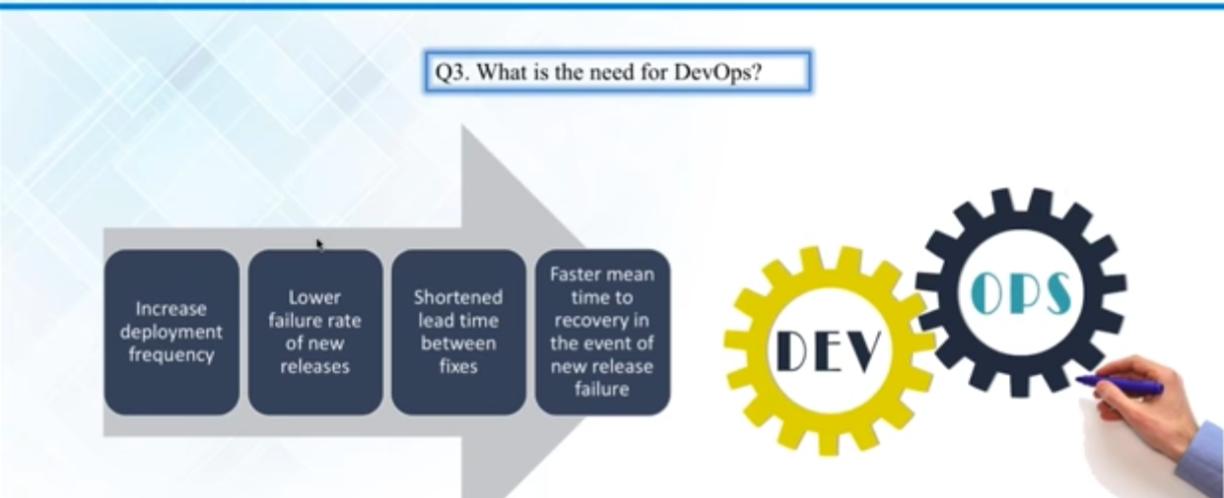

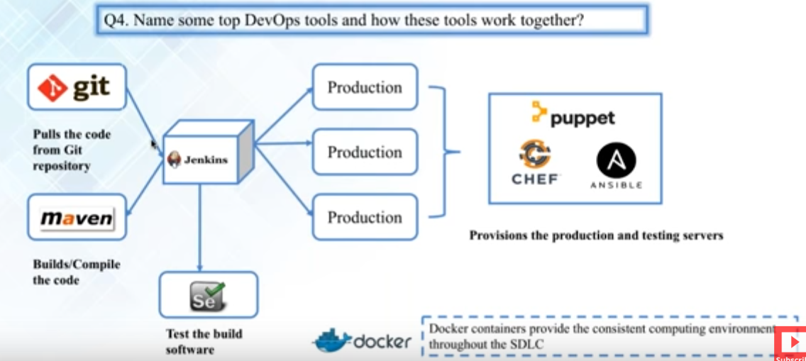

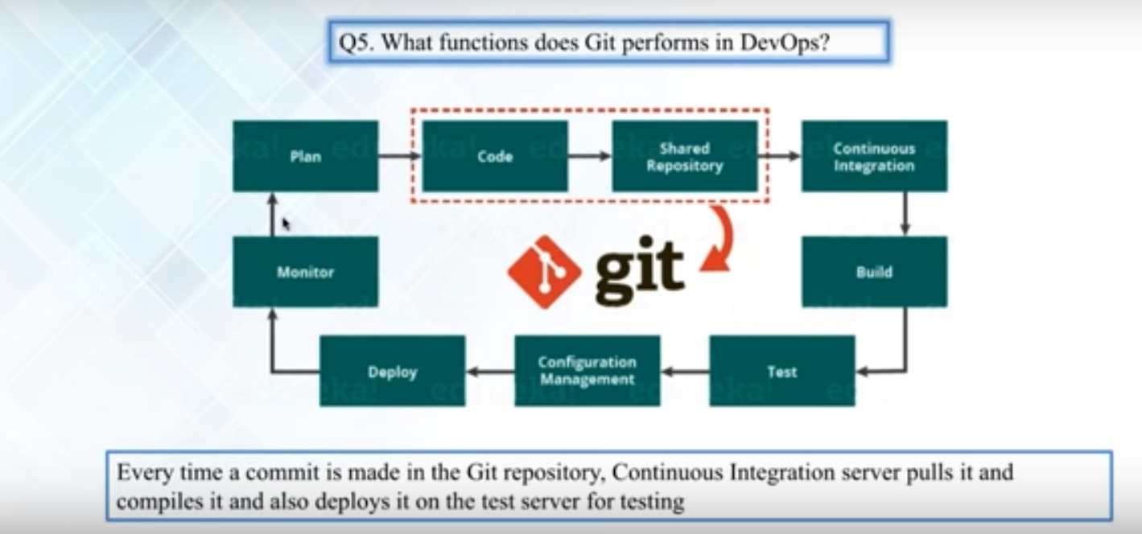

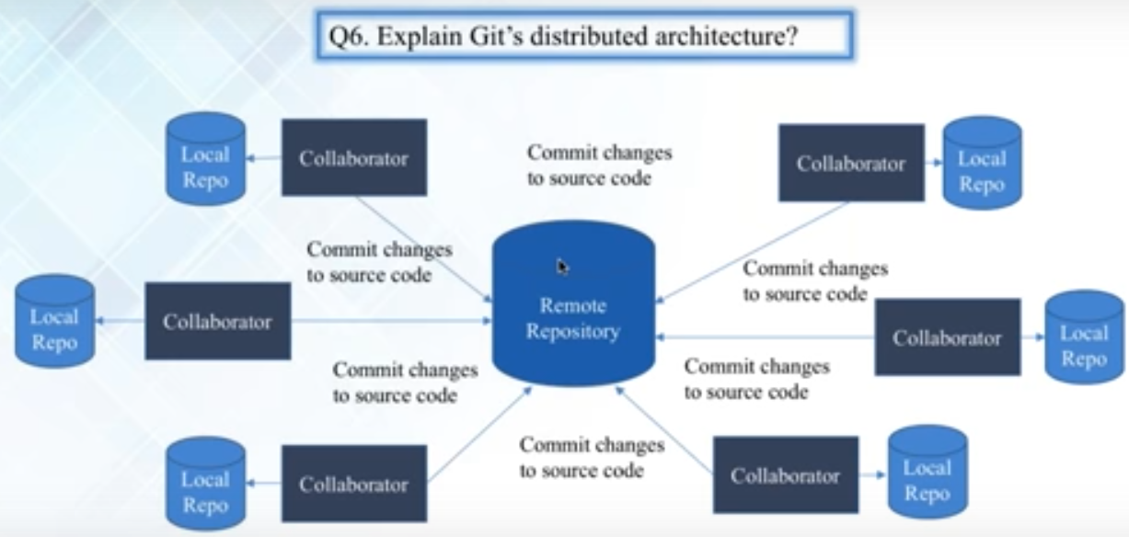

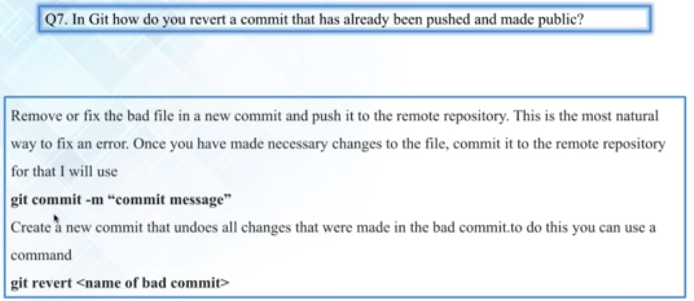

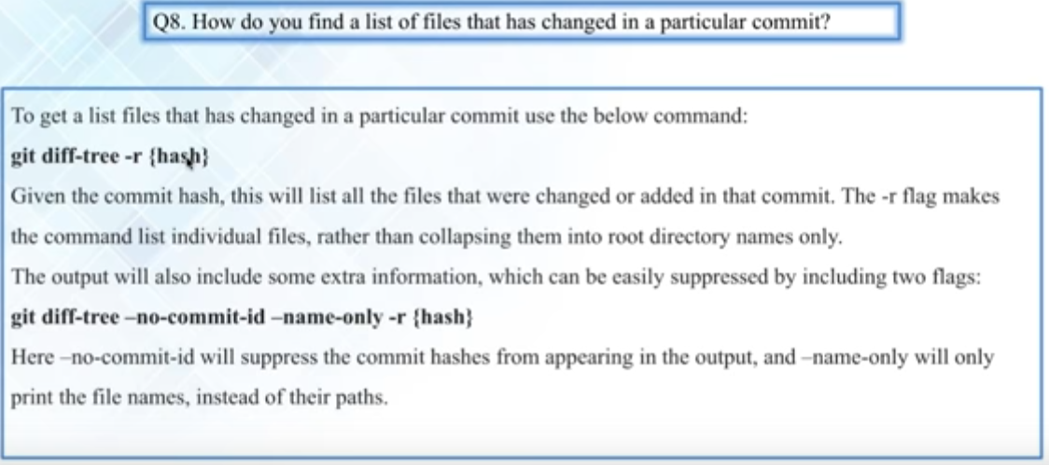

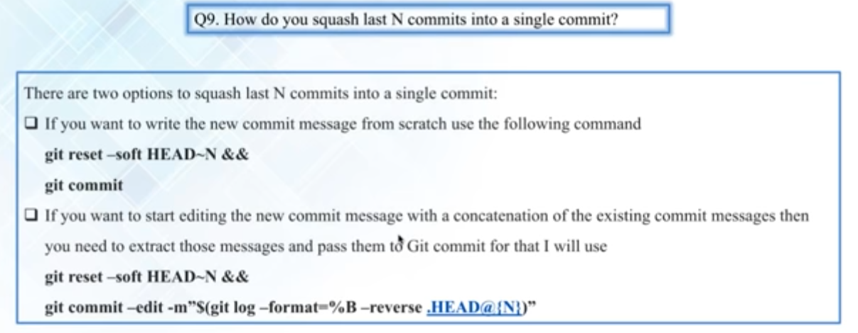

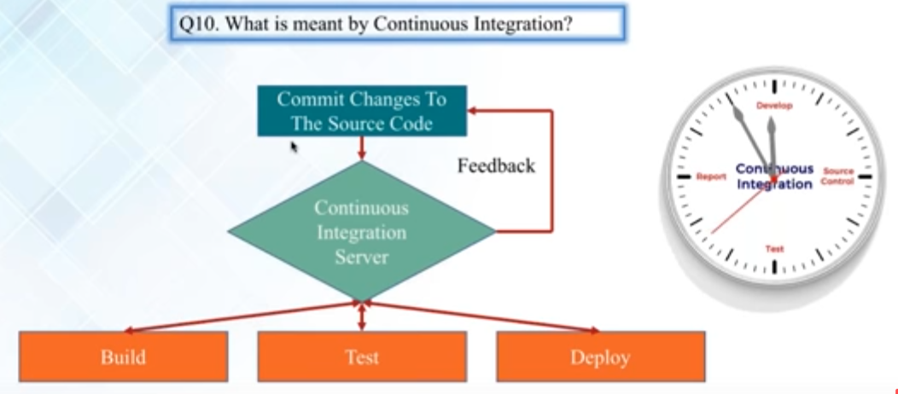

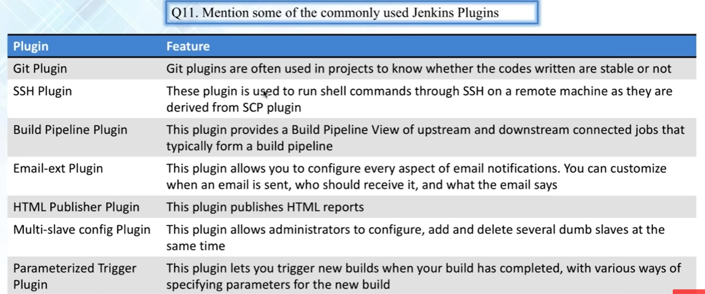

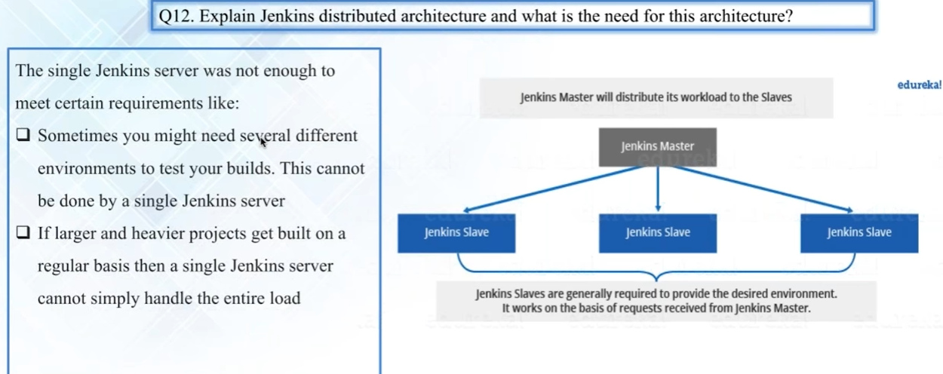

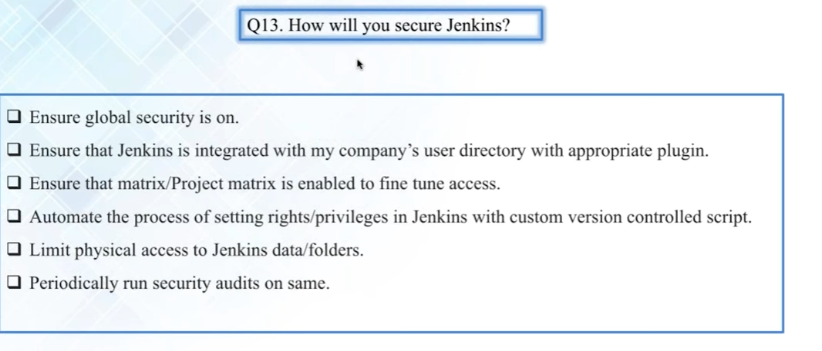

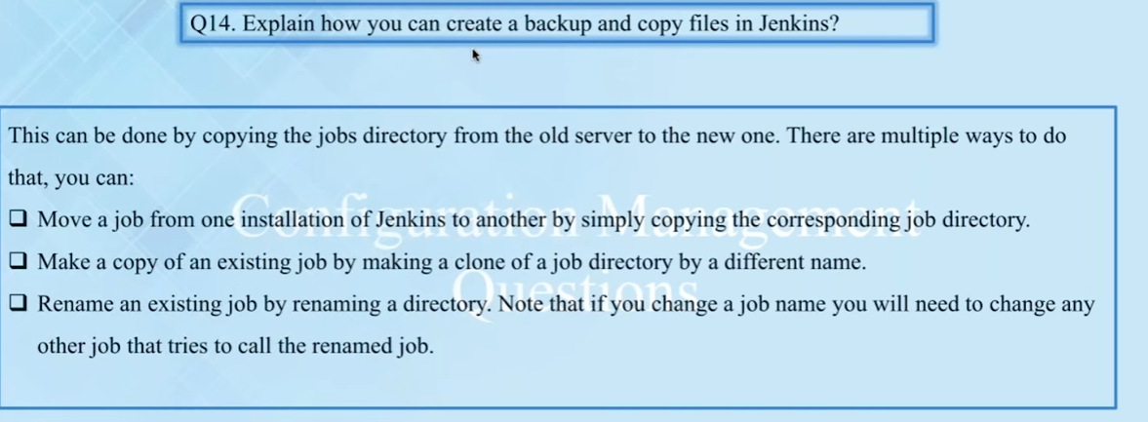

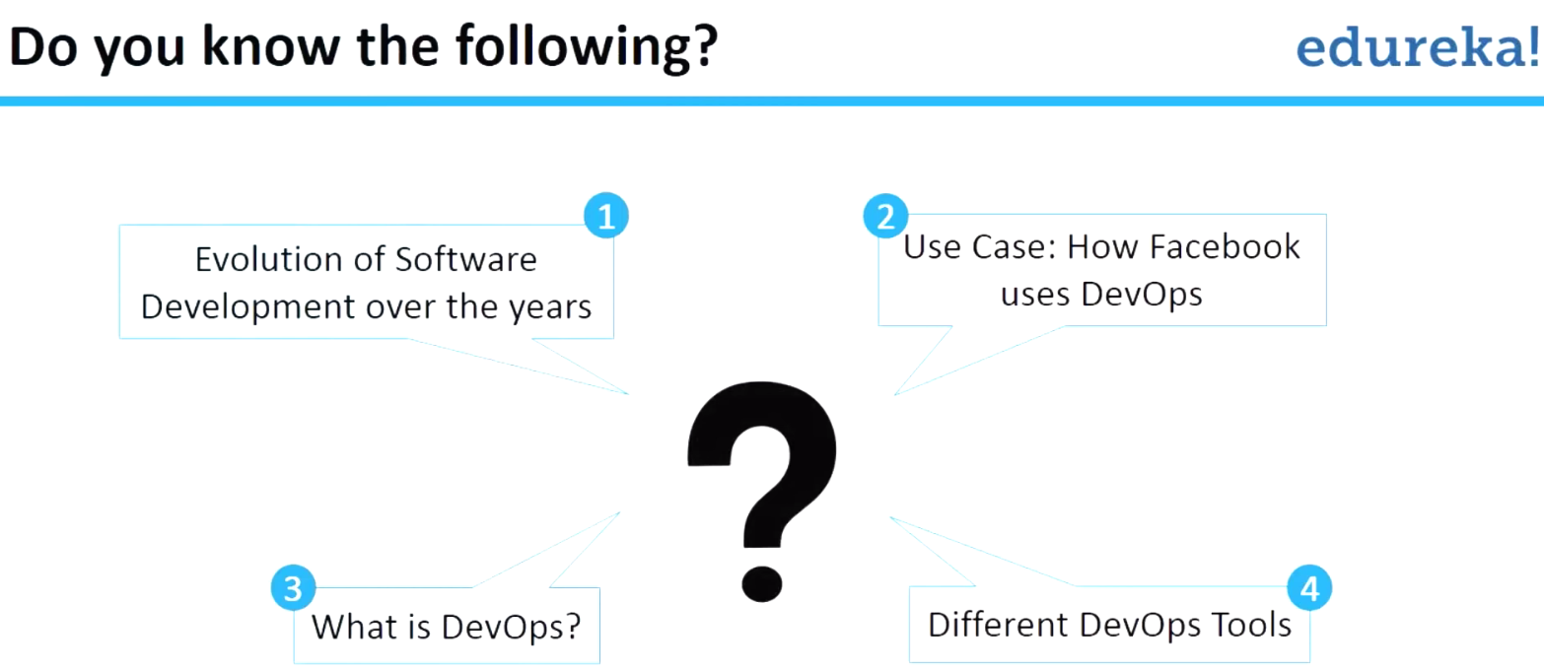

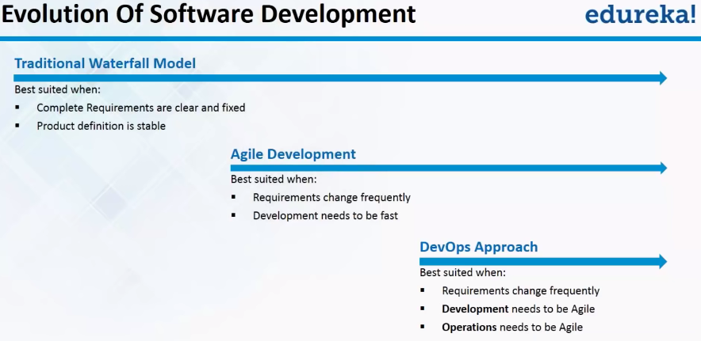

so it can be reduced lowered drastically by using develops practices right the next thing is shot and need time between fixes so if you identify an issue and how much time will it take for you to fixtures and then how fast you can identify designation right this is possible by the Arts practices and faster means to recover in time of a nearly failure so that's possible by the box because you're using continuous monitoring their actually monitoring the application after you really is complete to proactively you actually check whether the application is providing you know giving out required results or not and the instead of waiting for you know at the end of failure which will probably cause a potential business or reputation damage for organization you actually proactively identify the small issues of the gaps and then you fix them as well as possible and that's one of the you know important practical develops and so continuous motion actually deals with this particular topic shall increase the faster and then reliable software and then shortly times to fix the issues and then recovery time is actually much more faster in the even top an incident or figure next question is name some of the DevOps tools and how these tools or together why so this can be you know an important question like you can put this question another way like some person can ask you a question like you know you are developed professional and then the organization has given you the flexibility of choosing the budget and choosing various also if you are developed need architect or engineer what tools will you choose so to answer the question is this one first thing we started with a source control tool and the radio source control tool available it is one of the popular because it's the way it works and the creatures that it provides you choose it it is a distributed version control management tool and we actually see what's going on detail the questions about this gate but get will use it for watching control and then maybe one used for building and compiling your cold and most of the code is actually building jela and they actually can use maven because we went to wipe out of box features for compiling java code and then stole the artifacts in a proper way for example nexus is one of the architect management repository as solution and that is relevant variable integrated with maven so once you comply you can actually store the architects in a nexus repository for example so all these things can has to be integrated with the continuous integration tool cause Jenkins Jenkins is why use open tool so it's actually best in the organization as far as I see and it has a lot of features and plugins available now Jenkins can be integrated with the test tools selling is one of the examples for the web interfaces testing and functional testing and yeah and there's all the testing involved it can be decorated with Jenkins as well and the next thing is you have actually you know identified tools for your source code management your building purposes in your testing your continuous integration then I think it to deploy the application and in particular environment so to have an environment rodeo and running you need to have a provisioning system and also the protein system should be capable of deploying the application itself so for that purpose you can use puppet chapel ansible these unit rules can provide can be used to provision the sewers and then deployed application and provide the same consistency alternatively you can use docker for the micro service applications so dr. contains forward constant computing environment to the sdlc the doctors basically if you don't need a watch your mission and because you're running a small small applications like Michael silly says and then you can actually use that you're not quite your application so dr. is also one of the best occur in our protest it's not an alternate approaches but is one of the approaches so that's actually about the question number for the next thing is source called management question so here we talk about it because Kiki's that most why to use modern software source control management tool what function did performs window up so if you see the sdlc this is the picture of sdlc we're talking about planning the project and then start coding it and that coding wouldn't you start coding it you need to store that called in a repository and then you also should be able to share your call with other colleagues of your king so for that purpose we use called he is get to store the code and then share the cold with other people in your organization who are working on the same project and then we can further integrate that source code with continuous integration tool so that every time you do a change to your source code it will trigger billed automatically and then triggers test automatically and then apply some configuration changes in the placed in a moment and then can be monitored so all these things can be further automated so the show what we can actually use continuous integration say that every time a comment is need to get a positive continuous integration server pulls it and composite and also apply it onto the test server for testing purposes so that's the control get actually performs explain gets distributed architecture another question like how did you get work so give is distributed architecture unlike Sen the difference between history and get somebody else's this one it is distributed version control system sem is a client's elevation or version control system was distributed version control system means the deposit rate which has that all the source code and can have multiple copies in multiple areas i will explain that if you see that remote repository or in centralized repository for example or you can call it a more original repository is actually the original one the initial repository and then the each collaborator or the biblical actually take a copy of the entire poetry into his local desktop or laptop and then start working on his local repository kind of the changes and then push the changes to the mantra positively so that other developers other contributors can pull the changes and then start working on them so if you see that repositories having multiple copies right that's actually the distributed version control system but when it goes to subversion of centralized washingtologists which means there is a central repository that's available in a centralized server and then inch collaborator or each developer actually copy only the contents required to the desktop called workspace it's not the entire repository it's just the workspace with just the view that you can see only certain branch on the seven files you copy into your workspace and then coming to changes so that's the difference for doing svn and get no indeed how the universe a comment that has already been pushed and made public so indeed how to use we work a comment that has already be pushed in the publisher let's say you have actually using get and then you can run it coming and then you come in to change any pushing say hydrogen how you want to relocate so there's a good build command available to deliver the change so for example using get comic minus M combination of the first command college to change and then you have to use another command keep push to push the change from your local repository to visit multiple positive and once it is pushed to the multi positive you want to be able to change you have to use get a rework and then the common name so you come it has a half need to meet you just provided me and then energy would be coming I like i said the question and officers actually to the end so feel free to type the questions and then at the end I'm going to answer all the questions line so that we will not break the floor right the next question is how do you find alyssa files that are less changed in a particular comment why get offers various commands different is one of the commands that we can use to see the files that are changed so get different- on request you and then hatches with skills that comment cash so here the comic number actually is called fashion because it's just my other number it's a combination of characters and numbers so you just ate it coming to hash and then provided so that it shows the list of files that have been changed now that they give different provides the foolish like the origin the person the author of the comment and the timestamp and then the comic message and there's other the differences and all but don't want to see everything just want to see the file so the next command you get different- no complicated minus name only- are hashed it gives you only the list of files nothing else not even the comment i be all the hash right of this particular comic so it just shows you all the list of files that have been coming to our change in that particular comment like and we go to the next question which is how we use clash last and courage into a single coming and this is really interesting anywhere we need feature offer get in the traditional version control system once it is coming did you cannot change the history but let's get it allows you to play around with your version history or wasn't glass according to your needs now what is flashing squashing means combining multiple college into a single country for example you have committed for cabbage 1234 and you realize that all 4 comments supposed to be committed in single comet rather than having multiple comments because you wanted to share that common idea or the files with somebody else so for that purpose we use force watching this is called schedule use git reset command the recent actually researched the version history and what it does for example you want to comment change combine all the last four college in that case you need to do is get reset minus stock head filled out and sent to the number of comments from the head is the latest the top killed our admins the last and number of comments which means let's see if you're going forward then it's going to be last for college so once you your list man and then run and get comments such actually combines all the comments into one single comment so you have to provide a new comic message so that new coming that is committed will have all this for college the files are change so you're basically playing on what console similarly you can actually do another thing that you fear for example we wanted to edit you know the change would be you know the Edit message you can use a you know minus m and then provide some command for example get log- format pushes view- jurors and shows basically you're actually taking the same comment a message of all these previous college and then adding into this discount so that you don't want to even use the comment message that were committed in the past so another interesting advanced topic for a get so that's actually not yet and we actually now go forward to continuous integration now before actually I continue this topic I just want to take look at the question obvious because I feel some of the questions to publishing and then it may be related to this the same topic so let me just open your window and seen what are the different questions about the gig okay i think there are gender question i'm skipping I'm just talking about the gate questions when two people are collaborating it without pushing the cord indoors and what apology see if you have to this question from Arab so if you have to elaborate your changes you have to push to somewhere so for example either you can push it to the origin all you can push this change to the other remote repository so it can be your colleagues repository so you can push the change or the best way is actually push it and there are alternative ways without pushing to the reporter position but you still have to push to somewhere and that is actually to another local repository so that's being answer questions to the best way for the solution is to push a call right it's possible but it's actually a little bit tricky and it will measure of something now the next thing is can be worse this comet back to four different comments i didn't understand this question very well can reverse this coming back to four different college so see this crashing means we can deliver a come into four different college I mean we can reverse a particular comment to any comments that we want to for example you have like 18 n college and you want to go the work that you can't commit that's possible she just you as it was and then do the comic name so that actually easy answer to the question so now again there are some other questions provided by guys like do not give out if the company requires step-ups this is actually wide every company actually the collage if they wanted to sustain in the market they actually have to be about something that's what my understanding with our DevOps even though some companies they don't call them up they have some sort of practices so you know some of the other they're falling developed but it's really develops talks about more about the topics so the next thing is i will actually see the questions now if you have any questions will see at the end I will go forward to the Contras integration topic what is meant by continuous integration so confident integration is defined basically based on the comet that you're doing sure every comment that you do to a positive every change that you do has to be immediately compiled and build an integrated so that's called continuous integration so the continuous integration best practices that you do a comment on your own branch for example but continuously integrate the change to the trunk optimal master all to the main line of the cold so that it can be compiled immediately and then the feedback will be given back one of the infield or sexual so for example you're a developer you're working on one single feature and for that purpose in creating separate feature branch called censure and then you actually done you're courting you have compiled on your desktop perfectly fine but how sure you are that that cold actually works with the core that the other developers are actually doing it so that's actually his work integration we need to integrate your chord with other developers and then that integrated cold has to be compiled has to be tested whether it's working or not so that's actually continents integration so you kind of your exchange and then you integrate your change to other peoples changes and then you build and test been deployed so is the best practices if you really did the called continuous integration by just humble which is a very famous architectural box-to-box there is best practices for the continuous integration one of them that i like is that all the called by all the developer has to be committed directly onto the trunk and then the trunk or the main branch of the master branch and that master branch has to be integrated with the community integration server for example James are bamboo that actually should pull all the number of common for each comment the bill should trigger and then there should be an automated test the trigger and there should be a deployment that should be followed by this particular culture each comment is actually result in your bills and a test and optionally a deployment right so that's basically is about continuous integration and then mention some of the commonly used drinking plugins of Gentiles our focuses Jenkins here which is a continuation integration server and Jenkins will not work without plugging so by default if you install Jenkins it's just the shell without installing plugins you cannot use it so one of the basic interview questions about ok again the question of the session is basically covering only the basic into the questions not the in-depth the topics of interest because if you wanted to have any questions related to be an in-depth our specific parts feel free to enroll into else calls and where we're going to discuss you know several hours on each topic extensively and all the question of arms just can we were answered so some of these plugins that were jumping chooses this get plug-in or insane fucking essential because it has to be connected or a source control system but to monitor and message floating a very basic but he took the law into their motivations to do something more contributions of command copy files etc and then build a pipeline flooding so it's basically the pipeline is actually a convention McKenna's that you can use for you know to create an artistry and downstream connections so basically in the pipeline space where you can actually build you can see the entire you know view of your building and deploying to different environments and staging and production at Russia that because you can use build pipelines and then even extra plug in that space for the 210 notifications as soon as you get some results out of the bill and the HTML publisher plugin also to publication reports must be slave configuration plug-in and this is basically to allows the administrator to you know configure slaves things are basically the agents of you know making agents to run the jobs market under much silver and to manage them into English multi slave configuration plugging and parameterize trailer plug in is another client that actually lets you build based on the parameters second pass various parameters the building interface and there are several more I mean do just if you like it then that whereas other pilots like for example you want to provision you can use in a check but you know or if you're probably connect replicative yes you can create a bitch applied engine if you wanted to use it for example dr. images chicken is darker plugins and various other plugins and you can also use the some of the basic plugins such as you know maybe plugins of Jenkins for example and my dashboard police dash for all the dashboards and can use advanced topics like job by yourself to kind of manage all your jobs and just click here to hold the infrastructure of Jenkins ever call you can use job to yourself like an every other plugins can use it so there are some of the basis of the next question we explain drinking distributed our current architecture what is the need for this architecture lie so Jenkins is basically is a bcbg the architecture as you can see there's a master server that actually can be configured with all the jobs and the requirement and the other thing and then you can actually choose the particular job to run on a different shoulder right why because you know it's because your example you want to deploy a cold you know on linux box and then we want to apply the same called on a windows box for example or you know on a dif- distribution so for that purpose you need to connect to that server and then do there is activity said this all can be automated by actually installing junk enslave on each of things knowledge and then running it so that's where and then you have like religious environment you know each environment can be treated as a separate combination of separate place so drinking masters not just after you just need to have Jenkins slave and you can use as many slaves as possible because it's an open source tool and you don't you're not paying for this right so that's actually the distributed architecture of Jenkins in the next question is how do you secure Indians in other words you know what are the best security practices of Jenkins and you know so the question is you have to ensure that the global security is a parameter gain in the configuration settings are Jenkins you actually on so that not anyone like an anonymous users can access it so you have to do stripping an anonymous users and you're enabling actually you know security and you can integrate probably very well with the your activation of your company that is also one of the best ways and actually it's a good way of the secular your Jenkins and then the next thing is you have to enable something called Project metrics engine so you can actually choose who can access which projects so that's actually possible by project metrics in Jenkins alright you can also although maybe you know setting rights and privileges on Jenkins using custom control strip that's possible that you have to do some you know scripting activity for that one also you can limit the physical access of Jenkins and data folder and some of the folders so only drinking user can have access to that one if you want to the silver and then open Jenkins shoulder you have something called Jenkins state of all around jobs folder and in these folders can be also can be used to secure as well and the next thing is periodically than security audits and you know that's why the things that each other organizations to do kind of feminist looks like a complicated but it's not new just learning to server and every time and just see who's having access is there any change in the exercises are on script that actually monitors these doesn't auditor of the match to the right so explain how you can create a backup copy of files in Jenkins so this is also a lot of ways you can also migrate Jenkins of one instance other instance right the same process is applicable the way that we can do is actually therefore called jobs and then inside the job every all the jobs of the start she had probably can take a copy of the whole just forward alright and that actually did see that means you're actually showing it actually can copy are written component and a different mission then we use it so that's basically for my goals are changing or when you rename an existing job for example name then you have to also make sure that the underlying job surveillance to answer quickly these questions is a copy of the jobs order that actually does the work all right next to this configuration management before i go to this configuration management take a quick look at the question so somebody asked like what is the meaning of bisected me see and get command actually its use for binary and each use some sort of binary search our algorithms to kind of find which damaged in the projects introduce a bob so it's actually a little bit wants to kind of topic but it's actually you can use this for you know finding the bad comments was just be a good combination children's show again this is actually a little bit into the topic and so will document the colorful detail additional the next thing is on the condition condition of question is is nightly build a part of continuous integration and actually nightly builds our marketing solution continuous integration means you comment each comment to trigger a bill that's actually controversial expression if you read the book or just humble and december clearly face that night girls are not continuous integration why so that's the famous looks all most all organizations actually adopted the principles of defining that that will make sure i also going to work for that one so the observational the next question is what's the difference between CIN City continuous integration and continuous deployment actually very good question that there's actually a difference between continuous integration and and then the continuous integration and consciousness and deployment see continuous integration is talking about building your core as quickly as possible to get the feedback whether the building successful not right that you so each comical to build and then the corresponding test so that's actually introduced integration right and then the next to play this continuous deployment wins every build that into a more general market like a jar file or Muslim sort of fact that particular new artifact the result of the build has to be deployed contribution and modeling to kind of test it and that's actually complement deployment right and we also have something called see also stands for continuous delivery which means it actually talks about the whole large picture like SNL issues earlier called you have to continuously delaware that to production show dr. body and applying continuous delivery a continuous deployment your test environments and then the automated trigger define work for that actually automatically test stay and women test environment and make sure that is done then continuously deploy that to production so there are organizations that follows condition deployment that continued eligibility for example netflix does you know maybe 30 deployments for a day and they do quite a lot of department so the way to the productions that way to do it each come it will actually trigger a continuous integration build and actually create an article that our trip will be automatically deployed to a test environment and then the test environment will actually you know that the automated tests will run against that environment intersection school and it will be promoted to production immediately if it is saying then actually people go back to the developer and then they will get fix it and also this process will goes on this is actually a countenance delivery rather than conventional apartment so the next topic is a continuous integration management questions select explain the various configuration management company now this is not a mutant configuration management is basically your management configuration information of each of your resources or assets right of your organization for example your server is an asset and each server has a its own configuration information right and then it has to be managed properly so the phases of the configuration management is first configuration identification so I think that's why what other configurations for your results for example or effort so let's say you have a silver and then how many cities it has the memory and how many packages and start and what other computers configuration files of the popular and so were and what it is used for the purpose that it's been used for some weirdest things it's been you know where is quite a lot of massive information about each node and actually is the first beginning part of identification and that information has to be stored somewhere and in the olden days we used to call symbian configuration management database where they're all information is stored now with more than things like you know using such a popular interval so it's actually quite a lot of things are automated so if you install these two these configuration management tools essentially information automatically and souls into B into central server right or just a quick thing sucks hasn't once the configuration identification is done then you have to manage the change which is actually change management and change management is like each change has to be deployed properly and gold back in the end of the video so that's actually configuration change management and configuration shapes accounting so that's what actually is a it provides the stages whether the configuration item is working probably are not right and this is used for reporting purposes and then the next thing is configuration not identify the consistency of the documentation against the actual product but these are the principles of configuration management you know it's just for the two purpose and then when it goes to the configuration management the actual management of the tools like confidence which of the picture will be a little bit different but another question is put into question is what's the difference between asset management and a configuration management now and its management dr bought more about money it's about largest takes the kind of thing so but when it comes to configuration management will talk about more from operations perspective it's itl based right it's basically for troubleshooting if there are any errors when the lifecycle is just to deploy into the time right when it comes to the city management it is consumed with the you know finance like how much it will cost and in who owns it and then what is the purchasing and leasing process of stories and also called how to maintain itself was and attach ourselves basically licensing and all the essential part of this particular asset management well as controllers management is about deployment operations right so that's a different key difference ok the next thing is it's part of this what do you understand by infrastructure as called the infrastructure has court has been very popular in fact that lasts the whole practice of the opposite of the develops evolved from the principle of configuration management and the infrastructure Scott so what exactly means that you're probably an environment should start with a call so if you want to do provide a provision a dev environment are a test the production almond everything should be starting political should contain achill you have a cold and nutraceuticals that'll actually deploy all programs and water just basically you're storing the infrastructure as a cold but if you see the definition says I AC is automation of ID proof operations adjustability plan managed by provisioning of course rather than demanding process right so you provide their test and production environment using the cold and centralized location that's it infrastructure Scott the next question is what's the difference between push and pull in configuration management now why we need actually push and even pull during the conversion management is basically your scent life server actually stored the configuration information of all your Lots like you know what you're a contains not be candy no chicken things now if there is a change that a no needs to receive them effective mechanisms that was involved I decentralized in silver can push the change to the required note that actually push mechanism or the north we can define a pulling mechanism so that the north will consistently chicks with the centralized server and then updated whenever that is in need like that's actually pull mechanism i was actually discussing this one because there are some tools were kind of push based mccannon some configuration management tools were component-based countries management for example of ansible is push push method and other tools like a public chef and soul stank users pull waste recognition rights the next thing is how topic works why not pop it actually has a master and slave concept so you have a master server is a centralized children that will be used for storing all your configuration information about all your puppet flick obviously is actually a door where you probably running an edgy or and some kind of an application or bass or something so you actually manage those servers from the puppets lips to install pocket slave on the notes and then you install puppetmaster on a centralized server to manage your changes so the first thing needs a how it works is the purposely when it is connected to ssl encryption right all the sleeves are connected too much using episode chick you a layer secure socket live so now the first thing is the public actually slaves send the fact now what in fact is basically the configuration information everything about the slip like CPU number of CPUs memory I'm number of packages installed and quite a lot of massive information will be sent to put master puppetmaster distortion and public Marshall also have a catalog information would actually send to sleep this catalog is your number of packages initially installed and so our number of configuration changes that need to be done on a particularly slow actually compares the Kepler permission see if there's a deviation so for example there's one line that should be changed in a conf I'll alright so in that kind of 5 198 information needs to change so obviously I devices change and then it actually does the change once the catalog is pushed on the master server and then reports back a result right so the number but she says the node reports back the puppet indicating the configuration is complete which is visible Olympic cash book so that's how actually not it works why now what are the modules and manifests in public so there are two things about models and manages so manifest let's talk about on the lights and what is manifest now everything has changed the configuration information of a personal sewer or a retinol is actually stored in a native language called up native language and that these information are actually short and manifests so for example you need to install apache or I popular so that's actually a like called Apache right so this manifest actually contains the lines of court to perform some activity on an altar server now module is actually a combination of such manifests for example you can have a managed to install apache another managed to install the memory be another man says let's go to install and homecare so all these combination can be combined together and as a single margin and this can be reused so the modules so if you see on the left that it could modulate the collection of manifests and the Augusta did text files and templates and they have a specific directory structure models are useful organizing it's called properly and because they allow you to split your called multiple methods and you can actually choose which manifests to use for my particular module that's actually like you're not you're writing it and a double project like you're right in each module so manifest are basically single individual files and they're written in public language called extension in Sleepy is a pc the small example a snowed host to which is basically to install this on your clothes suit pocket called hosts to and you're calling a class called in attaching and then it's actually your defining rich that much like you know that apache host the module you're calling a module and then defining you know the name is examples are common and you're actually passing some parameters like research support is equal to 80 and then rock group is equal to the WWE history more so it's a small example I don't think can always look forward to our prophet com it's actually a community to open source community where people develop their own modules and then they share with each other such a good place to quite look for opportunities and so right in your own you can actually choose one of the existing pocket modules ok now the next thing is chap let's talk about Jeff and how the architecture explain the chip architecture now the 50 times for the chevy's chef so chef note and then Jeff workstation three different things that you have silver it's like puppets early the centralized store of all the infrastructure as a configuration information stored in chef server and then the check node is basically what justice ever manages so just not is basically your silverware Apache water regions for their applications running and you want to manage those knowledge with your chest server right now ultimately with Jeff workstation is actually your desktop or a server virtualbox somewhere you actually initiate Jeff commands right that knife is actually one of the commanders we use to upload configuration changes to the server so for example you want to change something called a cookbook what's good cook is basically a please or actually storing the configuration information all the your configuration template and files and everything on a target in a cookbook so for example you can write a cookbook at computer called you're right any jeopardy as a language which is actually it'll be style and in the cookbook you define what a condition is to be applauded into a particular check note that you define and that which a good book that could look at those number of packets required and you know the service of stitch you started everything combined together in a cookbook and that could book you have defined and you wanted to show that could look in the chips / so in his knife upload command-line show that command you use from the chest workstation so you do operations like changing the chip server information using chef at work station and then just actually silver pushes that information to the check notes y and c if you see this here on the purchased jeff frank runs on node attainment configuration information from the server and the client and knife uses API clients to talk to chef server right and knife is used to communicate with Norwich using ssh and systems managed by check or called notch and left side assist chef workstation is simply computer with a local chapter depository and it properly configured life commands so this is how it looks now if you just on the right you see all configuration first to test it on the workstation so if you write a cookbook you have tested so you can use to inspect our champion chicken testing tools to kind of tested on your workstation and then you push it to the cellar and then the chef server actually manages automatically you know pushing information to just launch it off with some process called convergence it chooses to kind of make sure the changes are actually popular question are the state of the technology is in line with what is defined in the chops over why that's actually the architecture now this example to write the recipe to install httpd and copy and exotics HTML file to be before documental to come from the insulation so a small example probably or somebody will ask him for you it's actually easy recipe there's a difference between Michigan the cookbook recipes basically just like a manifest contains the resources are to bring the silver interparticle state and then when you actually combine the recipe with all the templates and variables and all it can be called the cookbook and there can be various recipes some together you can combine several recipes as a1 cook just like you know manifest is equal to recipe and then model is basically like a cookbook so in property polynomial in and check you can call it a cookbook and then publicly called manifest the same thing you can call it that they should be trip right so here's package to begin a package is basically entering short it's called every short ingest and it's a predefined resource and we need to find package DVD actually it'll be installed package called HT pretty and so it is actually called illusions that actually start service are actually start services are enabled so you can actually define doing and do is basically like open brackets and and is like closing practice and you after the final action alright so if you don't know define action so by default there is some action associated with that particular resource that will be enabled for example you're mentioning here action enable promised art which means you're enabling the service called his credibility and then you're starting the service so if you don't define so by default the actual automatically starts because service action started people like we're going to see that later and the next is you're using of violations to copy a file to target rather be w HTML and XHTML do open packets contain your writing the content into that file is welcome to patch in show so this is basically test and then end it the simple kind of a script alright so the next thing is what happens when you don't specify resources action so like I mentioned so for example put it the first example is final see users administrative staff report setting sure they do content going in equal to lower so you're actually basically not getting any action but whereas if you see the next snippet call it says action call and queer train both does the exact same thing it creates a file called settings on I and then what the country called greeting hello world but the next thing is you're explicitly this thing and actually called create and if you specify action called create it actually creates even if you don't be fine actually created that before the action for final results so that's why it actually gets executed because created the file resources default action situated another into question so under the different question is all these two generations of the same so what is the difference the first one is such as a shitty so we actually do action able starting the next one is started service into the package and then starting a service called HDD and then later it's in running back initiative insulation so by seeing it the way that Jeff works is it was two sequential from the top down so the first one is correct because it installed the package and then start with the second one is included because it's starting the service and then install the packages but there's actually a strong you have to install package first in order good start though is otherwise it'll community the package does not exist so the first one is correct so the answer is no there not because the chief applies resources order to help you so the first recipient shows the history detectives install and configure service the second recipe configure the series and then ensure that the packages installed which is actually quite what the next question is about ansible invincible apush based on a probation seem to like explain before edible works on a push base the mechanics of multiple days how does it was you have a sewer and simple silver we have actually kept all your playbooks alright and then those plates can be version control right and then all we can do is actually what animal does and shovel you have to specifically to write a tangible commands to push these changes to the various other three knowledge that you have and then by default and civil users as a search to connect to the gmod and sellers that you're managing all right and then the other into question the famous into question is that you don't need to install interval agent on interviews necessity of managing there's no such thing called interval agent there's only one can call in circles for you install and civil and a tangible on a server right and then as long as you're the silver is able to connect with FSH and run the remote commands are using ssh onto the bomb your server can manage it all you need to do is you need to configure your inventory which is basically the number of hosts that server is managing and properly in the Indian venturi right as long as you can do that and it can actually manage it so that's actually a difference between also you know push-and-pull mechanism and also the way and the Lord said want to issue a dancer believes you don't need to install an agent on each box so quick into the question can be another question can be like how let's say you can be a slight you know you have a 50 different linux boxes and then you're able to do a message from your box to all these 15 years servers and then you want to install the particular application on this all these boxes resulting in doing so the simplest thing to do is you know you are unanswerable it can be one command you know to install XP apache on all these notes just write a small playbook now here are the cookbooks and Jeff is actually same as playbooks interval so we call playbook sensible to try to smile clay book and that actually installing patches and then run ansible command and specify a number of hosts and that actually goes coming to the way is it and install the HTTP package and then it was that the status of the update about the Holocaust the next thing is how integral architecture looks like right so as I mentioned like answered and mentoring inventor is basically the whole number of holes that you're managing and then it has something called up labels label cases same as that cookbook playback as modules and mah eyes and plugging i always think so each flavor you know use some modules using api's image users points are people able to basically called that your eyes and that calls these various existing predefined module right and then ansible automation engine has you run the PlayBook against an inventor e you define a playable to install the country for example and then run the PlayBook against an inventory that imagery and be a new ad servers are development boxes are production so life and cmdb is actually connected which completion information and then all the hosts of its managed so this is a simple very simple architecture that y all right before we go to the next topic I want to take a look at the questions i see several questions here questions about is answerable only uses push mecanim answerable us users only push Mackenzie as far as i am aware my understanding goes about mine and I have somebody's i have heard it can be used for pulling mechanics mezzo probably as Sarah but i have not used it and the popular way of using ansible instruct so we're talking about here not a trick question but include questions why we're talking about the introduction to issue an interviewer asks this question he probably is expecting push from you like but if you wanted to say if you can also use this pool then you have to prove it not what is the plugging exact plugging that uses my feelings i have not used answerable for purposes right i have you only used to push and that's the most of the people use ansible for an answer ability famous for push your answer it should be pushed what we're talking about like tracking into the questions sometimes you're probably more wider than the person is entering what you just need to answer your question correctly what the guys are actually asking you so that actually issues sexing the interview like and then the next question is what's the difference between tools like just cancel puppet and docker so Jeff ansible probably there's configuration management tools like to manage the conclusion so for example in the olden days just an example like i used to manage like various environments like 10 development environment and you work environment and production servers like you know and moments like the moment has senseless with his temp service production has extensive range of the sensor has its own role for example independent Devon ones one so is useful application the other one is used to run from back and services the other one is a database server and then we have a cluster of all these things like inches none other than patients now always interviewed actually is a very good infrastructure what happened she when we promote called the park call from one of this environment to another environment the deployment is successful but we have some issues so the plumbing goes smooth but after starting the service something that work on some of the issues we stay in Congo and this is imputed probably why because the configuration of each of these environments are not identical white which means there is somebody has done some small change to an Apache file or change the registry entry in the windows are probably changed a you know fine-tuned some memory parameter in Lexi in the database right of the server and as a result the development everything work fine but when it goes to be ready it didn't work it is that small information that configuration change has never been recorded anywhere right and that purpose to manage the consistency between all the environment we use configuration management of why we do it anything that any change you do we do is using either if you're using ansible use a we actually do to play books and which is against audience version control if you're using heavy-duty using cookbooks and profit is actually perfect modules and an offense but that's how we so that we actually reprovision environment would apply the playbooks all these in a configuration information to the new environment of the existing environment so that it will be automatically updated in match with is that you know exactly what we need right so that they will not be any figure at all when we actually deploy the actual code right so that's what the purpose of the configuration management tools darker on the other hand it's actually for watching relation purposes right so there's a difference like difference between watch realization and dr. we're going to cover that topic article in the next upcoming slide by the next question and easy model fused for defining a classes can we deplore a module Derrek Lee on the on the public agent yes we can actually deploy a particular module directly on agent right so now a module can have a default class so basically every module should have a class and if you don't specify a closet actually takes default class so that's marginally can define you can actually run against the population that's possible alright next question is for provisioning infrastructure on a cloud which tool you better pop it on Jeff both are equally powerful show in order for me to commend each really and wife it depends upon you know the person thinkers and been the person XP wrench so for example if you're more experienced with puppet you can use carpet because even the licensing cars are more alleged same update if you're using for example AWS cloud i can just use an example AWS cloud has opsworks taking integrated with Jeff right so probably you default option would be to chapter four years in club but probably also equally powerful institutions pocket provision AWS cloud and most of the people i use with like you know those who use open stair they actually use public like it's just you know how you work with so my understanding is pop it goes well if you're using OpenStack and Jeff goes well if you're using a look at it appears ok it's just a default but you still converse attended blood exactly and even much better sometimes like okay is installed the production yes it is installed ADB protection for package resource right now which is better push or pull mechanism well actually depends so for example from case to case so if you want to do one time activity right you want to install problem servers and then using provisioning service can be done by to push mechanism because it's a one-time activity but I'll mechanism is to kind of once your provision and then it's connected to an environment and you have to keep on the ceiling the updates and for that proposition is pulling Tennyson why next question is it can be done by creating dr. images and applauding it onto the doctor i'll come back a little bit later in our last section called virtualization alright the next topic is about a continuous monitoring now why continuous monitoring is necessary convenience monitoring allows the timely identification of prob and weaknesses in the software to redeploy and it actually reduces the expenses of the organization because you're finding the issues earlier and after an incident is happening and a financial or other additional damage of a particular organization because of the service video so you're identifying the potential failures in advance rather than in an office sometimes it's being proactive so this is done by a solutions that the dissolution of business you know computers already been monitoring and transaction inch pension you're inspecting certain things now why don't we need continuous monitoring and that's what we have seen at what does negative work for so we're going to cover here- how does it work so negative is a open source of monitoring tool and this open-source might seem to always use for you know monitoring your applications and basically negatives it actually just server is a transportation centralized command your silver you actually installed in your server module in particular server that's actually used to centralize Lee to monitor all your applications all your servers so it's over agent based client server based application and this negative steam and actually has a processor RS particular it has a schedule that actually change the results on a our excuse the plug-in on a scheduled basis on a reference braces and so basically all you do is you install the negative server on it- silver so that you can monitor the local resource like all the cpu memory all the information monitoring of the thirties information about the castle and you also can use something called at remorse over management so using negative silver you can also manage the remote agents and for that purpose you need to install another plugin called and RP which it will see next is like so basically measures comes with quite a lot of plugins so like a you can use by default when you install basic module contains nothing but when installed plugins which plugins or contemplated section so you can have a plug-in to monitor the insecurities as you can have a wanted to plug in the disk space so all is playing based I so you need to install the language the processor scheduler or server and then anything installed negative plugins right that will be executed by this processor and then that actually gives you the information right so the first thing is negotiating skills a bug in the next segment plugins checks the stages and gets the results and that they're being is plug-in chances up to the majors to process and then- actually finally display that information in a web GUI interface line and then this plugin it can be anything a local plugin all this plugin can also execute the honor the more box you can see the second number two here again takes two stages and gets that it offers remote host right in order for the motels to work we need to have another plug we're going to feed in a second and notifies at number 4 is notified I've been about the status of processed by the scapula so notifications can be sent either bias and that's our by email so in order to manage the remote host which is very important we have been installed something called Nick use them or plugin executor I so this remote plug-in we have to install on it are remote box for example here if you have the most linux and unix those were NRP installed another package to install this monitoring closely because of silver legacy were actually runs a model college she can RP h and this chicken RP actually connect using FL to the NRP service which will monitor where is information like check this check load chickety chickety chickety people are always take this too close and all they are clogging and solve locally on the local box and then here we have installed a an RP plugin and now on the remote box we have a chicken and our opinion plugin which actually connect the NRP and then pull the information about the most part and then shows it on the web interface ok this is actually concept or negatives to understand death we need to actually install and do some hands-on like but these questions kind of can give you some kind of understanding and if somebody asks you about media's anything I'm not worked on the years probably the best thing is you can just gonna say that you know Biggio's service to be installed on the server and with write plugins that silence electron be run and then give the information about the trip you all remember and and then can be displayed on the legacy of those and similarly to monitor the remote host image install a plugin called megastorm or execution plug-in by that can actually know all the stages of the month box why ok what does make us check for external commands right now- strip for extra commands under the following conditions at regular intervals specified by command check interval options in a main conclusion and so actually can set up at regular intervals command check into a little option and then country there's some kind of way for example 20 minutes of 40 minutes that actually been vigorous will check for external commands the intervals and also immediately after even handlers are executed so 17 even to actually handles are executed you can set up sex object that you know to run the external commands and this is the condition to regularly recycle the man checks and it's not to provide immediate action even if the handles of which commands to the years or will direct the next question what is different between active and passive check in vegas now actually the major differences a few checks are initiated by next year's El Paso checks are performed by some external application so you can probably have an application that actually still wanted to pull some information or do some chicks through magazines so you can actually initiate and interactions are checks by funding applications or that's called pathologic and your negatives can do the checks that's actually depicts a passive checks are useful for monitoring services that are singles in nature which means it cannot be monitored effectively by all in their states on a particular scheduled basis right so what happens is that the negative now you can sleep on Angelo in the negative server that can check the status of our particular series on a little but what if your application doesn't depend upon that regular interval but it just needs whenever there's an information so in that case is unique and special cakes and also if they're also was located behind a firewall means your regular slot works and that case you also have been busy passing another monitoring holes to go to monitor the do the passage x-rite the main feature extra tix are interested by girls at the extra tix of Ansan and regularly scheduled basis there are two important questions like a few checks means initiated by nichols and then on a scheduled basis paychecks mean initiated by some other application in the England of where you don't actually play on the schedule information like out flat detection so what is actually flapping flapping means stopping because when a server auto service for remote holes state is changed every frequency becomes ready because being very frequently so you actually confused what exactly it's basically it's becoming red one time is becoming Queen becoming red green so that means it's actually very inconsistent and how the manuals deal- deal that it's a slightly different actually installs the last 21 checks the results of the last 21 shapes in a and so is analyzing the history checks of the rules so it's basically it restores the last one checks of the holes are serving as a historical connections and then the next piece it uses that state transition to determine the percentage of change value of the measure of the horse away which means it's check that last 21 checks and then next check should actually compress the difference like the percentage of the changes it's been happening then it actually compares a person so see it whole store service is determined to have started slapping when its present state change first exceed the high flapping this also there's a theory that actually there was a little clapping happen so it shows that flapping information so the current state is actually extend exceeds their the clapping states then they're so resistant to minus 2b and flapping but everything's not then it's not planning so it's actually the mechanism that actually in our biggest users right and the next thing is a hostess is determined to have stopped Reggie when they posted a state goes below the flapping press old so there's a flapping result they remained by the first 2.1 chicks and then it actually measures will actually come by I was that value to determine whether it is flapping or not flapping why alright so before we go to the next topic i'm going to take three questions here which is better megazor spunky negative widely used and has already you know why lot of support but negatives is a little bit complicated to kind of be installed to manage so people use also splunk so i have actually extensions videos and it's actually a little bit tricky and you need a quite a lot of expedition to work in vegas is one guiding it a little bit easier than and necklace alright so you see that the tools like OpenStack uses magnets as a default monitoring tool is very popular and it's there from the very beginning that's where negatives popular melodies what are the containers show here we have come to the containers and virtualization techniques so virtualization pretty much everybody not so we have a big box like Proust example a blade machine with 20 pieces are another dance and it sounded processes and hundreds of GPS you can split that and you know box into multiple virtual boxes so each project can be used independently operated of these virtual box so each will silver requires some kind of resources like it requires a memory is required shape you require the disk space and it's a track so that we know about the modulation but what is containerization right or discontinued that containers country start a kind of anti-environment application right and all its dependencies library language configuration files and everything bundled into one package that contained raising an application platform and its dependencies remove the differences and always distribution and planning structure that the definition would explain this not locally now if you for example want to quran pc only one box and then you want to run an application that actually runs on open so let's say you're using that hardly makes and you have a host machine but you want to run a small application and activity and I opened the box and in a way you have been installed vertically another separate server called would do and then run it and that requires resources memory and then separate virtualization virtualbox but using containers cleaners are lightweight applications that you know provides a runtime environment for your holes for example you can install the container called could do to run your apache in your host mission itself so that very lightweight and they don't need separate what your boxes you can find it on your own box right and all you need is a container engine running on your host box the container engine will actually make sure to install on your host box and that actually we're on top of that you can actually start multiple containers and each container has its own runtime and woman it's on one time vehicles inch on runtime linux kernel and so forth so how this is possible it's possible through something called Abu total now if you see the images of the container they are pretty smart like 10 mb or maybe maximum under the MP but whereas you see what toolbar it's actually can be up to find mb to several gigabytes right so that's where containers are very you know record has only essential information to good that application and provides a great run time environment and can be run on indicating on the sandbox or so for example you can run upon binding on the same box and after binary on the same box and have separate and binders and libraries on the same mission show actually used for microservice publishes the next question is imagine a scenario where large application is looking into small composable pieces of each of those pieces have their own setup dependencies that of called independence this piece of that microwave right so microservices are actually you broke the application into small small application which can be run independently and which has its own dependences and so you're actually breaking your large application to small microservices and in order to on each of these microservices what we use news containers or what relation so basically we use containers and not what your mission here the reason is because if you use virtual machine into elimination you actually have to create a virtual mission for the mikaelsons you have to need several my congratulations which means you need a large ship you in all the resources you need to use consumed so lots of movies of memory but if you use content you don't need to extend anything your critical infrastructure can be as good as your laptop where you can grab container for each other application right show HR microservice so that's actually the advantage and lightweight doesn't use too much cpu memory just launched only the service if you install what you bought it runs so mrs. but if you can absorb container it only once one service and that it makes life so let's see a difference like right and aquifers to create image and image into MongoDB mature know this example why Daka file is actually storing all your information about your container and a particular file so when you actually start this no part in creating in clinton with all the rules that you have to find this dr. fire so actually what you're doing is you're actually the first thing always in a doctor file is from open from and then the image the base we call it as a base image so the basic nature can be going to can be read hard or can be ap linux sol pine XR you know it can be a windows notice we have windows with the severity light which small images stored in as something called either a dr hopf which is actually Public Registry of where our vocal images are stored so we need to do from google first this actually pulls it would be small image into your host machine and then it actually wanted other commands that you're actually defining so here this example were installed we're running a container and that actually installs a mode image so let's say we wanted that suppose we have downloading or going to image and now we're updating run apt-get update without creating Jermain Taylor is basically the name of the personals office image right thought of this container and then we're running at the apt get update so you're upgrading your repository and then you're actually doing is basically a command that we use to to involve any commands like a nominated to run and then specify something that will be in or on the image container machine right so run apts it means this command will remain actually installs a key key into your repository of the next thing is you're running equal at the issue DPT downloads and this URL defend them and then you actually piping into one file call the socialist mobile dealer so you're typing this deb information into this file so that's the meaning of this command and the next thing is you're doing also the apt get update which is actually operating your repository and then finally installing mobile BB called apt-get install minus y mongodb can jack and then you're creating your a MPL and then you're exploding a port numbers so this is important because if you don't expose a chord then your host machine radio-controlled container will not recognize this report alright so for example a MongoDB on the container lunch with the port number 2701 seven and what that port number has to be exposed to the host mission so that first mission can recognize the pork right and then you're actually running with cmd with minus minus port to 70 17 and then finally you're actually running an entry point into the point is basically the process that actually was so us had been one BB movie is the closest that you're running so if you run this particular doctor file and that actually creates an image alright so once the containment created if you log into the container using THC and you go and run for the processes you will see only one process called use our been motivated nothing else so which means it's a lightweight right so that's actually about the docker images now the next question is what is an example explain how broker is used for sdlc over this is important questions of how you can use the darker right-to-left thing i have an application for running and that actually runs in httpd HDPE your service and then you have some contents of that HTTP like in a web application and let's say you want to use dockwise your application what would you do so you have a cold and you have to find the cord your copy if you are local desktop are you actually shorter than a tenth repository and then in order to test this clothing with water love you can actually use the documentation mechanism so you guys the dockerfile and the doctor files are you know from do you say we do and then you install run the commands like you know if they get updated and able to install HDTV mm you and I copy command actually copies the your code from your repository to the container and then run your history the application so that's a simple circular actually have a profile at it again in a negative positive 3 and then you actually have a profile now you have a cord and you can actually integrate that with the Jenkins so the Gentiles actually wants to build is done it actually runs the local file that creates a container and that containment can be tested negative it can be a testing a container that can be tested you can like to test the selenium tests to kind of touch another working final off and it can only exactly same thing to kind of traditional shame dr. file you can use with same your cord to spin up staging and production environment so exact same thing would actually will be open so for example you have a close to mission like production post and you wanted a new container so simply wander near dhaka fire and that actually brings up a new doctor container so that's easy actually useful continuous integration alright so that's about you know it feels somehow local provides constantly competing environment through sdlc so we have actually seen I've already explained all about it so let's say you have a project cold and then that actually has a dr file and docker file actually has a docker image and then the local container and the local image actually pulled from a dr appt for example from able to actually pull the image from the dog on piano right and then branch things up & open container and if you run this call dr. file you can actually start the server right in a staging same thing actually can be started on the production so its eggs i can see paper source that you're taken to build a container she is your source you seem and so the constancy should be process why then the next question of making this lasted about what is dr. composed alright so actually one container can have a multiple you can actually you can use that dr. Campos file you kind of deploy several containers life not one single doctor for example what we have seen and just an example before a docker file is about one container but how about you wanted to show multiple containers and then we use the darker complexion a darker composers yaml yet another markup language where you can actually define multiple you know dr. files like the copies of the document files whatever you have mentioned the doctor fire similar thing you can mention like you can have a few lines of code for going to start your web application container and then to post customer base container and then british gesture and containers so these three containers can be together locked up in a one-dollar compost fire and then you're on dr. Campos that actually spins up three different containers with one single command that's actually be that she can run these three containers with a single command using docker compulsion alright so you need to install dr. Campos for that into the boss so before i can actually continue I just want to take a look at the example so simples is a question states and suppose if I need a lamp stack on my watch so i can use tools chef puppet and to do that so the question is my understanding is you want to start a lamp stack on your note and then what we'll use use a chair for update you can actually use any other things to start lamp stack so what you need to do is for lamps and lenox which obviously is your application and for example appreciates all continents and then my school and then PHP you want to install this incision right a for example using chair you can write a cookbook to define to install package like dependent packages and one single cookbook and then on the cookbook for gage at the club no and neither actually installs the lamp stack that's actually good example ok the question is but at the same time i can write a docker file to upload it on the docker hub so that teams can pull the imagine building containers that's right so in both cases I can usually deploy lamb steak yes you care so what the dockerfile is it as you can see it's like lately and you can have a single container image for all your lamps tactic right using docker you can create your own doctor image right that has a lamb stanking and there are actually examples in the dr hopf right all that's actually nitrate why not every application i can work on a lightweight it's a question probably you probably have a dedicated so were called for attaching a dedicated server for my skill dedicated server for your PHP learning in that case and they are available already you're not changing the service you have an operation everything its television already and there are physical markets like virtual box in that case you use puppets or check to manage these dependencies and the installations right that's the difference when i use dr. why I need tools like a paid internship actually if you use a doctor in this instance well there's less you don't need to do much with Chester but Jeff and operated actually it can be used to stand up for provisioning are altogether that brand-new so so basically if you're running a darker image you don't need actually a chapel of people that work but in order to run the documents you are probably running on a host machine and that first mission should have all the installations to be done it should have a doctor engine running it should have a ridiculous like in a public it is running because you are probably running dr. file that actually copying stuff from your get your image and also for that was used checkbox that shook chest and operate or any other and configuration management tool together with docker actually gives us the best results why because we're not just talking about running its small container on a barn and I enterprise-wide how you do it so chef at robert has its own purpose doctor has on purpose you combine them together why to kind of make it a more enterprise-wide you don't print practice so that ok next thing is before I end of this question in this wanted to show you what summary of the sessions we've actually seen and the general DevOps questions and then we've seen the source code management and you can get and that we are actually seeing the continuous integration best practices and also the you know using a little bit about Jenkins and we have seen the configuration management push-and-pull mechanisms and difference between various information management tools leopard Angeles chef I continuous monitoring we were actually seeing awarded an RP and how this necklace work will seem containerization an example of docker file and then dr. Campos the difference between dr. composer and dr. file in its basically you know a dr. fire you actually run one container you can combine multiple containers into one single dr. Campos and running in dr. Campos so the next question is in a large introduced in order to facilitate microservice architecture yes it is it's not actually just interviews to facilitate microservices architecture it's actually introduced to see when when their options introduced it was introduced when these popular concepts of art you know configuration management and infrastructure has court has started right microservices like modern architecture and the dog stops you don't have you cannot have microservices architecture that's for sure but introduction of develops is not just for my Christian substitute but also for normal architecture like all the service-oriented architectures that we already have with many organizations so whether you use microservices our mark their options to the requirement for a debility and for the quality of your religious life and for microservices it's like a master and mandatory one all right so you guys have any other questions if you have any questions feel free to pause if you have any feedback that you wanted to give it to us you know i will spend the few more minutes to answer i know i want to all the questions you know a while running these maybe not but if you still do have any questions you know i'll give you a few more minutes you can cause them that i'll try to answer them so is that there are no questions from people so thank you very much for joining this section and hope you have you know learn something myself alone something yourself from the questions you guys have posted thank you very much and hope to see you soon bye bye I hope you enjoyed listening to this video please be kind enough to like it and you can comment any of your now degrees and we will reply to them at the earliest lookout for more videos not play this and subscribe to our Erika Tallan to learn more happy learning